Table of Contents

Source Code
Prerequisites
Compilation
Word to PDF Conversion
Check File Protection
Apply Protection

Source Code:
You can download source code from here.

Prerequisites:
.Net Framework version 4.5 is only prerequisite of to run this project. If you don’t have .Net framework 4.5 installed in your system. You can download it from here.

Compilation:

Compilation process is very easy. You have to perform few below given steps.

- Press Ctrl + Shift +B to build Solution. So solution will download necessary dlls from NuGet. I installed all dlls from NuGet.
- Make sure that AsposeWeb.DesktopClient is your startup project. Otherwise Right Click on solution -> properties and select AsposeWeb.DesktopClient as your startup project.
- Press F5 to execute a solution. After execution please make sure that IIS Express is running in system tray (see Fig: 01). Otherwise you have to execute AsposeWeb.Api project first then execute AsposeWeb.DesktopClient.

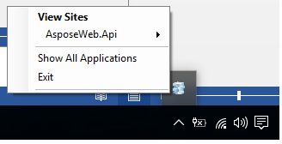
Fig: 01

Word to PDF Conversion:
To convert word document into PDF you have to perform below given steps.
- Press Browse button to select word file
- Wait few seconds and you will see a converted pdf file path in Output box. (see Fig: 02)

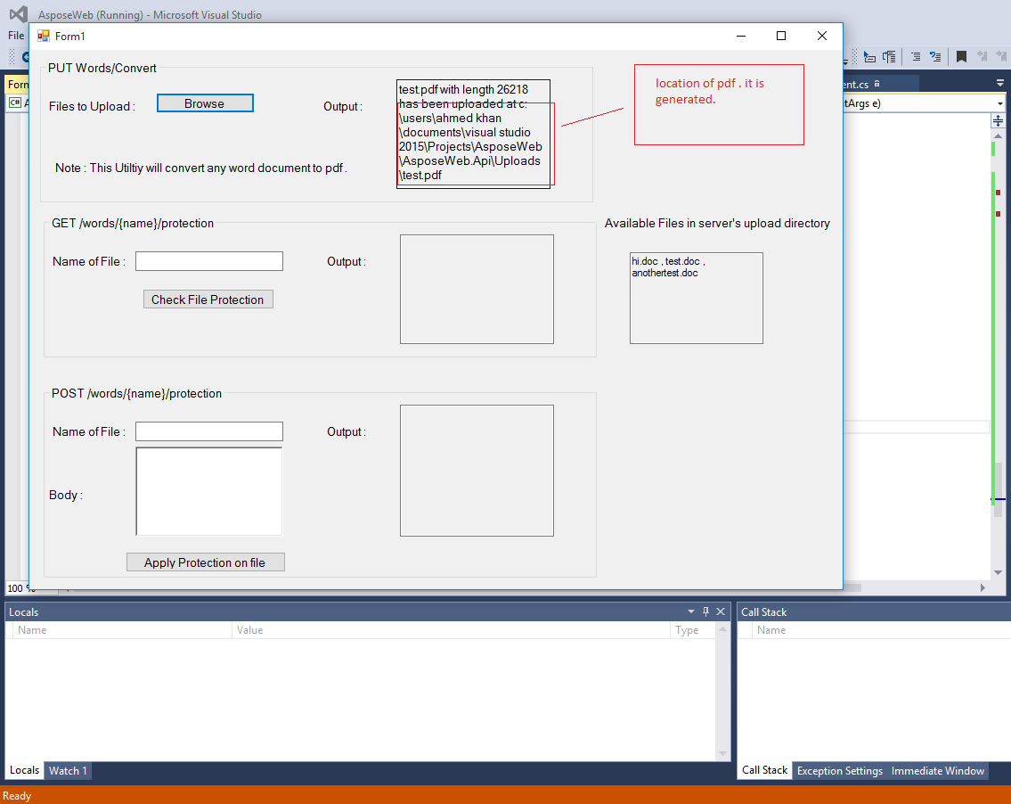
Fig: 02

Check File Protection:
To Check protection of file please perform below given steps.
- Please type name of file available on server. For help you can see list of available files in Available files in server’s upload directory box.
- Press check file protection button and you will see the protection type applied on a file in Output box.(see fig:03)

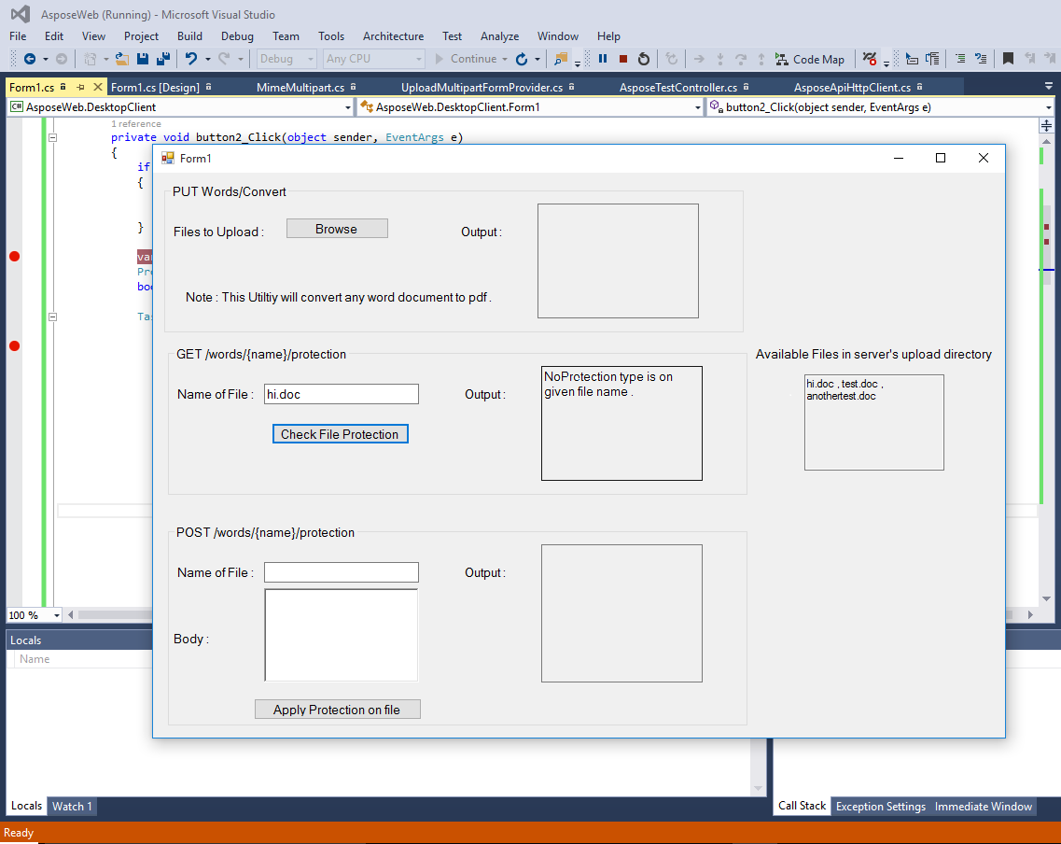
Fig: 03

Apply Protection:
To apply protection on file please perform below given steps.
- Please type name of file available on server. For help you can see list of available files in Available files in server’s upload directory box.
- Type password and protection type in JSON format. (see Fig:04)
- Press apply protection on file button and you will see the protection type applied on a file in Output box.

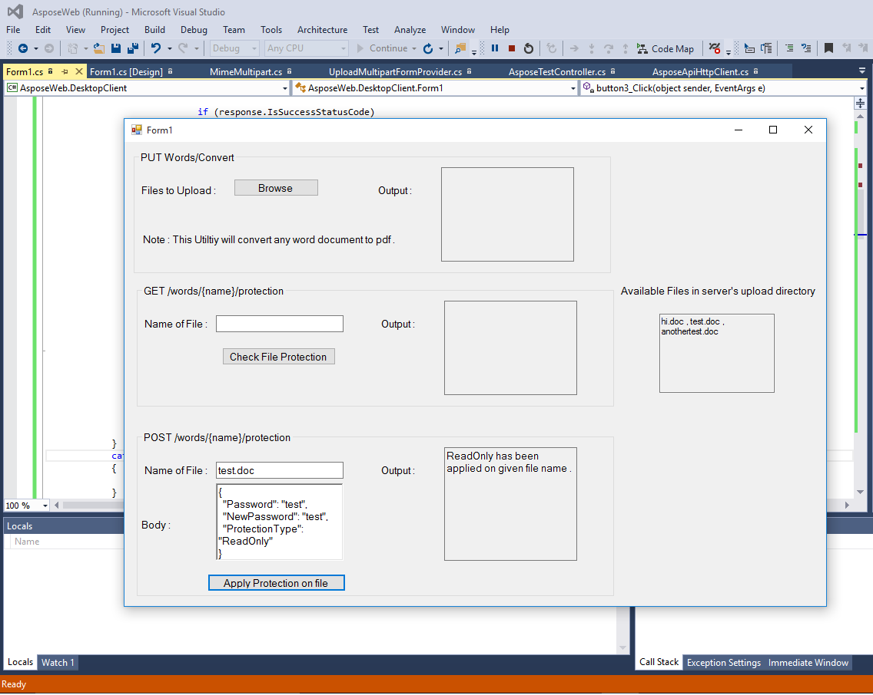
Fig: 04

